Assignment 2   
  
Name: Ayman Khan  
  
  
Servers used:   
JenkinsPrime (To host Jenkins),   
HelionOne and HelionTwo (to host .war file on Apache Tomcat)   
  
  
Installations on JenkinsPrime:  
  
1) Git   
Command: sudo yum install git   
  
2) Java  
Command: sudo yum install java OR find the latest version of Java online  
  
3) Maven   
Command: sudo yum install mvn   
  
4) Jenkins   
First the Jenkins repository should be downloaded from the Jenkins website. This will save the repository in the /etc/yum.repos.d. after which the key provided along with the repo should be downloaded as well. This key will provide the password when Jenkins is accessed later.   
Command to install Jenkins: sudo yum install jenkins  
  
  
Installations on HelionOne and HelionTwo:  
  
1) Git   
Command: sudo yum install git   
  
2) Java  
Command: sudo yum install java OR find the latest version of Java online  
  
3) Apache Tomcat   
The .tar file for Apache should be downloaded from the Apache Tomcat website into the /opt/ directory. The tar xvzf command should be to give access to the Apache Tomcat folder.   
  
  
  
  
  
  
Jenkins Jobs:   
  
1) GitDownload: This job was used to download the SparkJava GitHub repository into the /var/lib/jenkins/workspace/GitDownload directory of JenkinsPrime.   
  
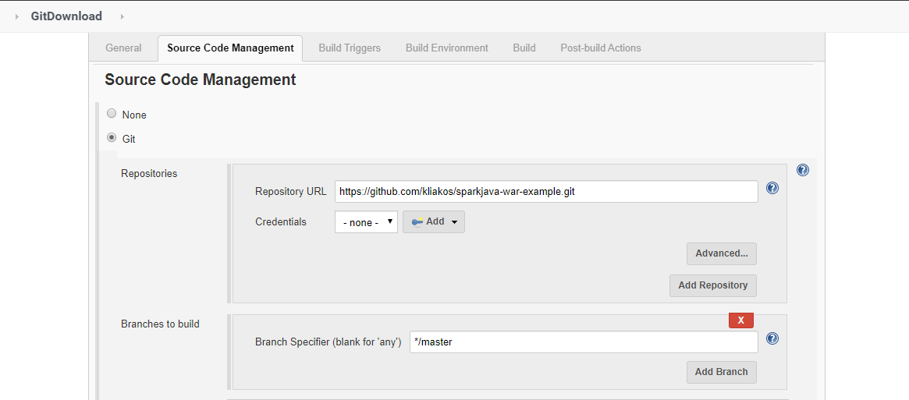  
  
As seen above, the link to the GitHub repo was given.   
  
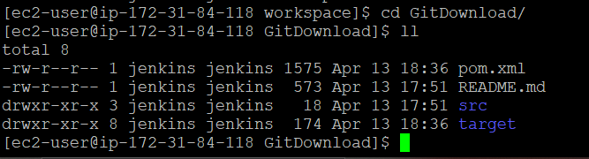  
  
As seen above, the files were successfully downloaded into JenkinsPrime. (The target directory is a result of running MavenBuild.)

2) MavenBuild: MavenBuild was used to resolve dependencies and to get the sparkjava-hello-world-1.0.war which would be hosted in the Tomcat servers in HelionOne and HelionTwo.   
  
  
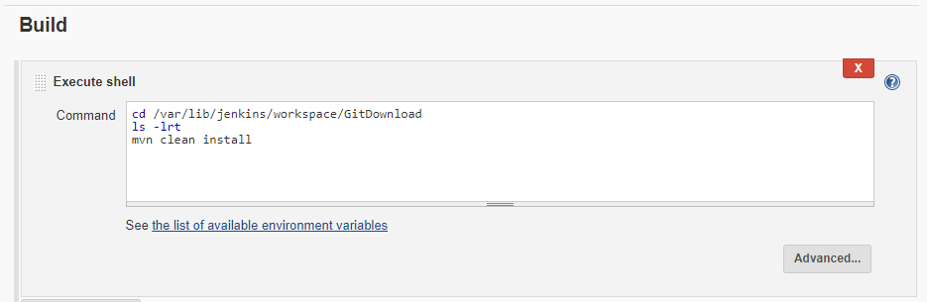  
  
As shown above, MavenBuild’s configuration had a build step which executed shell commands. These commands would go to the GitDownload directory, list the contents of the directory for the console log and then executed mvn clean install which would make the target folder in which the sparkjava-hello-world-1.0.war file would be located.   
  
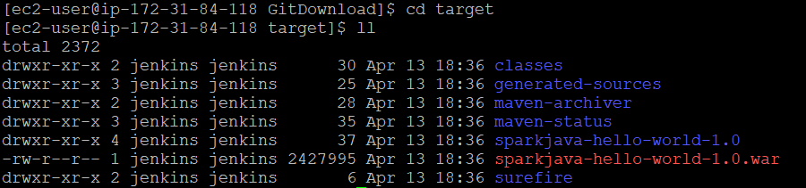  
  
As shown above, the target folder which the sparkjava-hello-world-1.0.war would be made upon running mvn clean install in the build step.

3) TransferFiles: This job was used to transfer the sparkjava-hello-world-1.0.war from JenkinsPrime to the /opt/apache-tomcat-9.0.34/webapps directory of HelionOne and HelionTwo. This job was also used to restart the Tomcat server on HelionOne and HelionTwo.   
  
Before this job was configured, the Plugin Manager was used to download the Publish Over SSH plugin. This would be used to send build artifacts over SSH.   
  
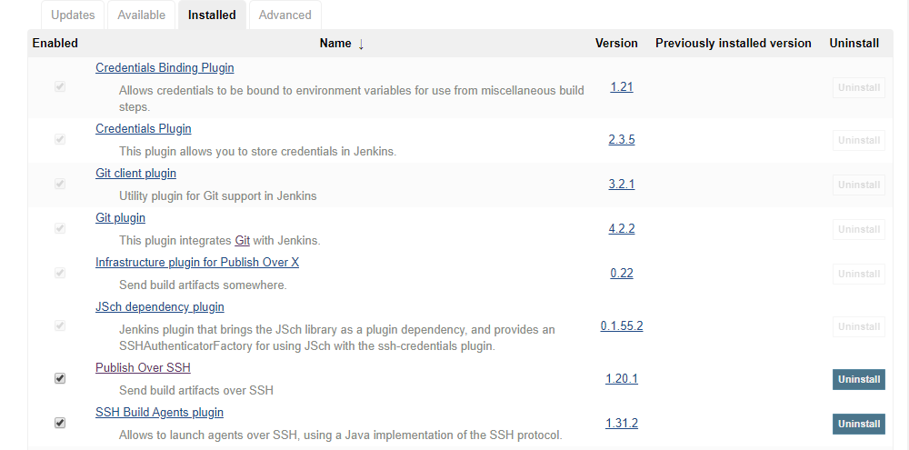  
  
After this step, Jenkins was configured with the RSA key, server name, server username and server hostname of HelionOne and HelionTwo.   
  
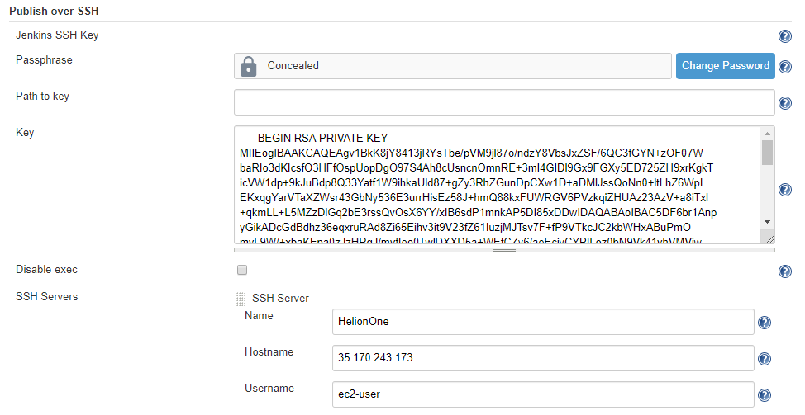  
  
Shown below are the send files or execute commands over SSH configuration for the TransferFiles job.   
  
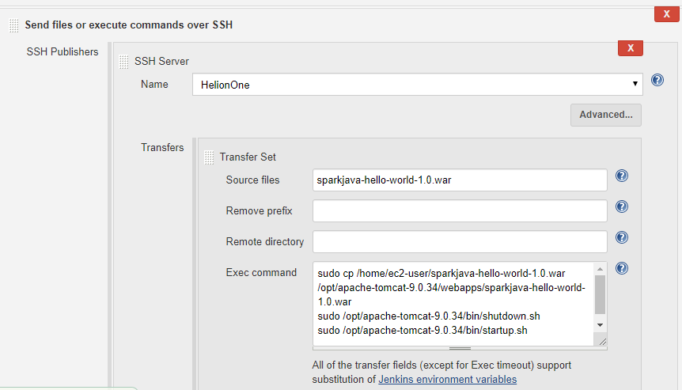  
  
As shown above, the sparkjava-hello-world-1.0.war file from JenkinsPrime was being sent over SSH to HelionOne and HelionTwo. Exec commands were added to move the file from /home/ec2-user directories of both HelionOne and HelionTwo to their webapps directory in Apache Tomcat to as to host java program.

4) SparkJavaPipeline: A pipeline job was made to orchestrate GitDownload, MavenBuild and TransferFiles.  
  
  
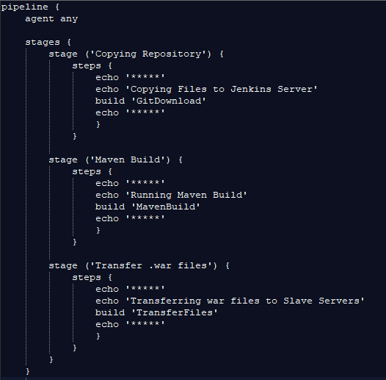  
  
The Groovy script shown above was used in the configuration of SparkJavaPipeline.   
  
Upon running the job, the following Stage View was observed.   
  
